### Using Bluetooth APP

**For iOS system:**

1. Open the APP store

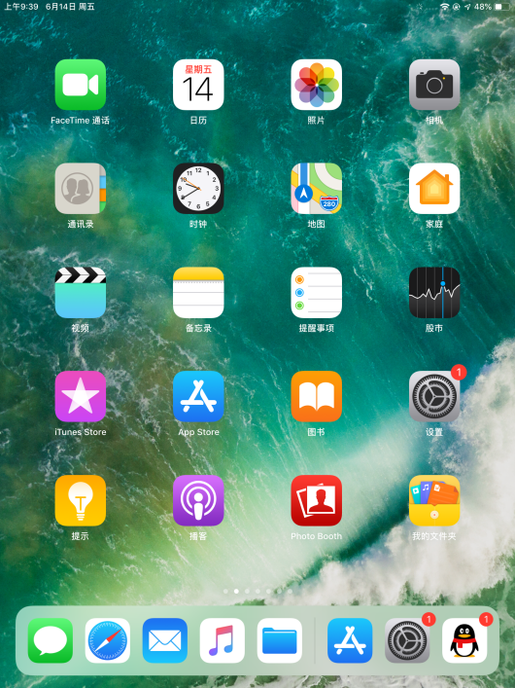

1. Click to search the APP - Frog Otto

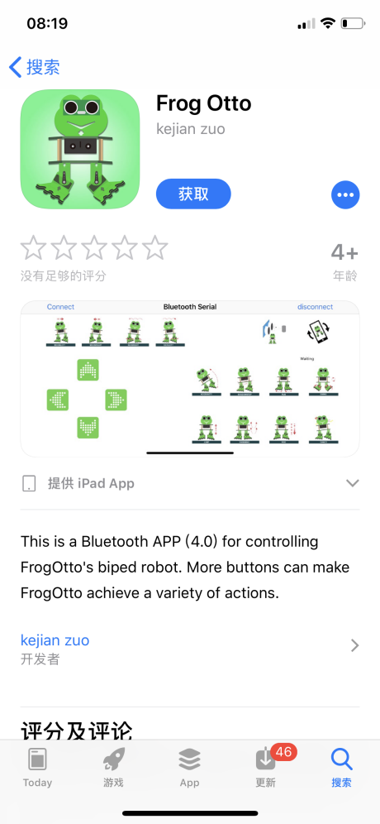

1. Tap to open the Frog Otto

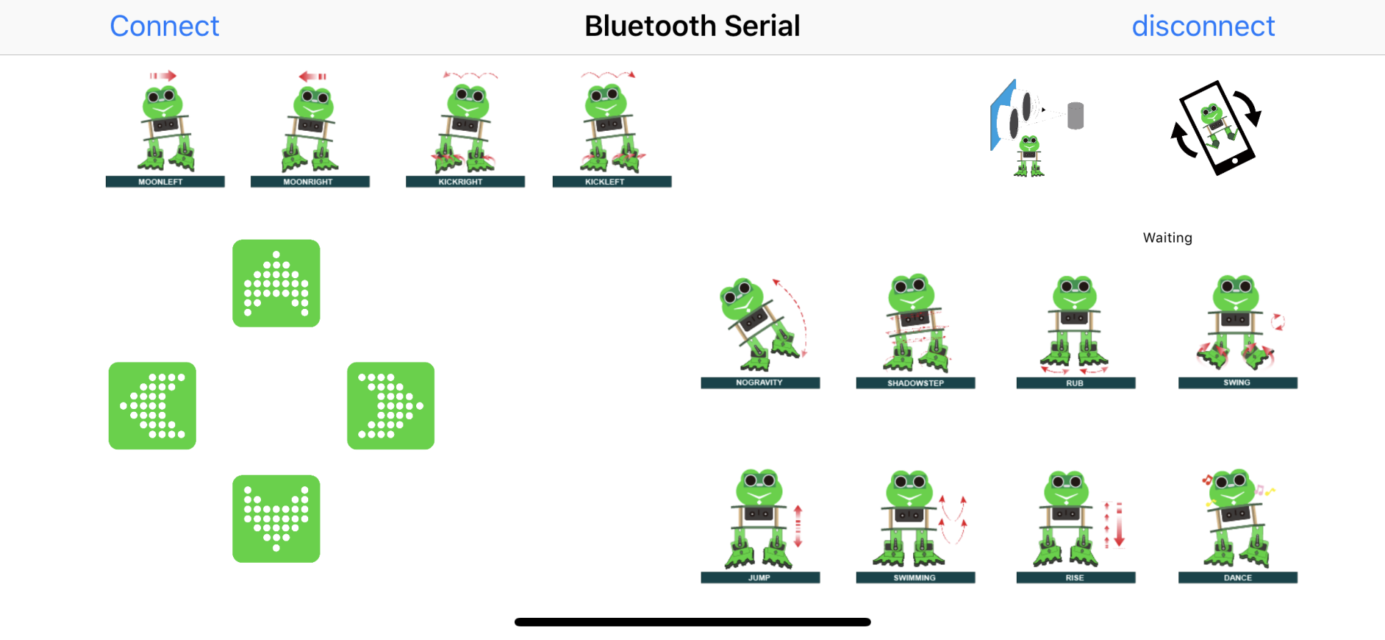

1. Done uploading the code, connect the Bluetooth module, the LED on the Bluetooth module will flash. To open Bluetooth, click the “Connect” on the APP upper left corner, searching and connecting Bluetooth.

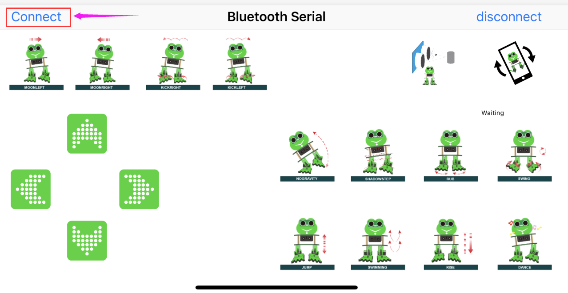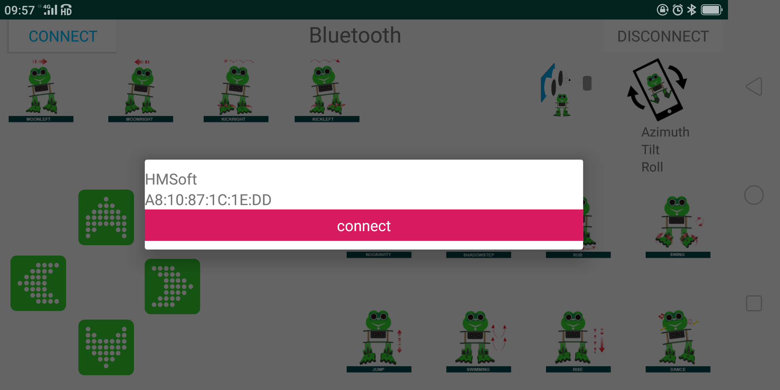

1. Click to connect the Bluetooth. HMSoft connected, Bluetooth LED will turn on normally.

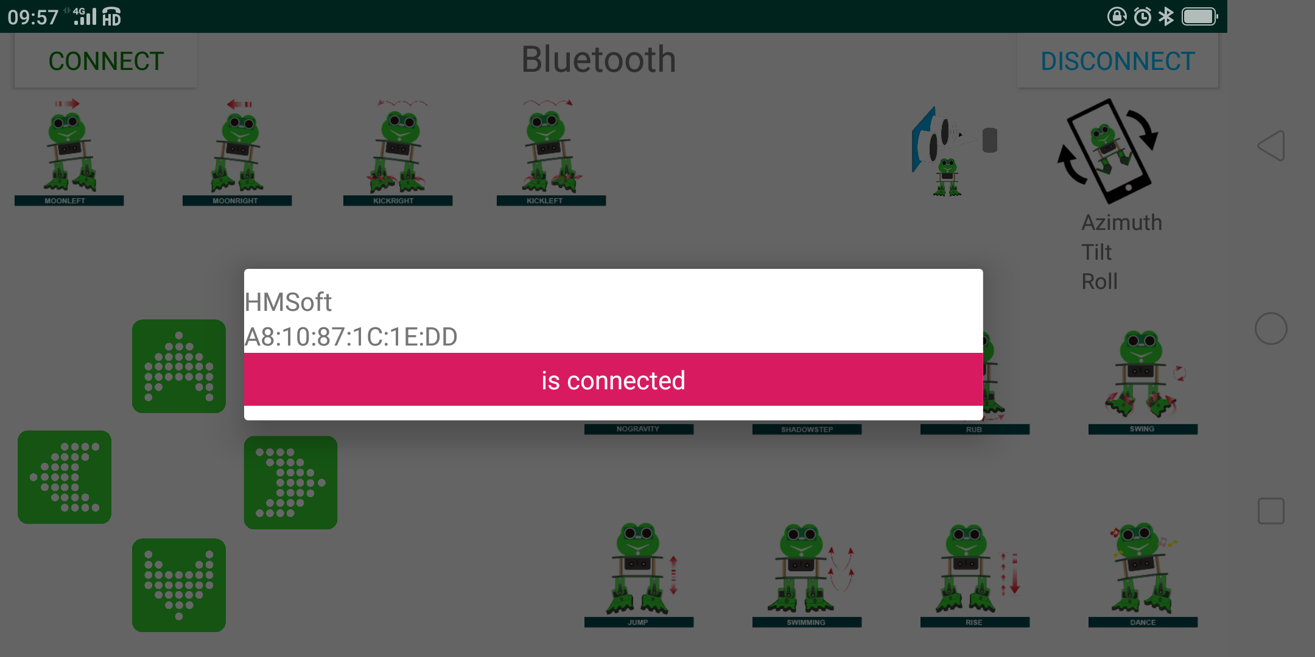

**The Bluetooth APP interface is shown below:**

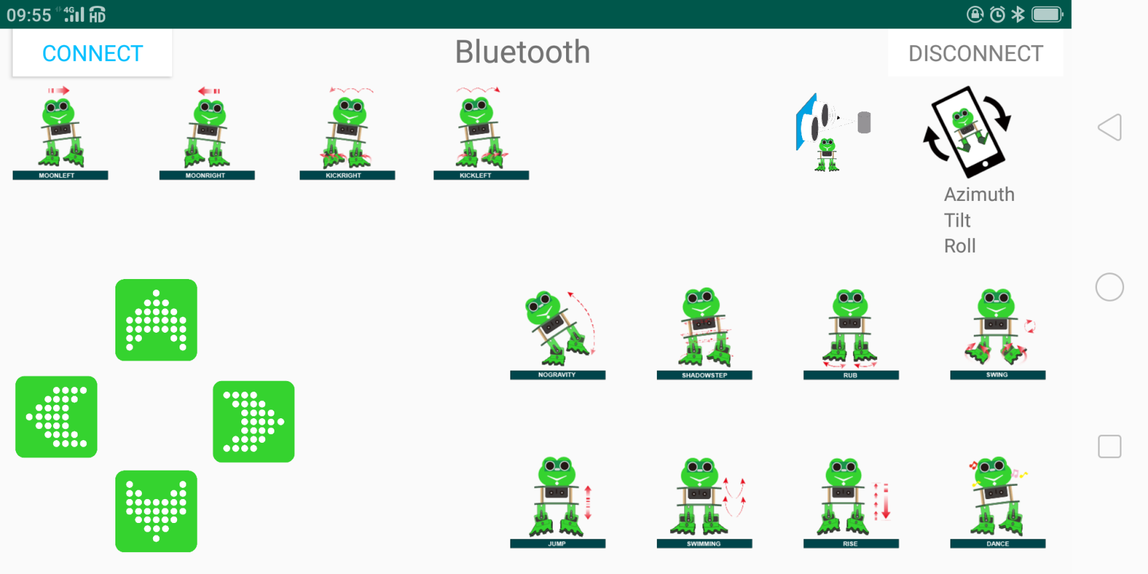

|  |  |  |
| --- | --- | --- |
| **Button** | **Function** | |
|  | pair and connect HM-10 Bluetooth module | |
|  | enter Bluetooth control interface | |
|  | disconnect the Bluetooth | |
|  | **Control character** | **Function** |
| Press: F  Release: S | Press the button, robot goes front; release to stop |
|  | Press: B  Release: S | Press the button, robot goes back; release to stop |
|  | Press: L  Release: S | Press the button, robot turns left; release to stop |
|  | Press: R  Release: S | Press the button, robot turns right; release to stop |
|  | Press: 1  Release: S | Press to wander left; release to stop |
|  | Press: 2  Release: S | Press to wander right; release to stop |
|  | Press: 3  Release: S | Press to kick right; release to stop |
|  | Press: 4  Release: S | Press to kick left; release to stop |
|  | Press: 6  Release: S | Tap to tilt right, then slowly turn back |
|  | Press: 7  Release: S | Tap for SHADOWSTEP |
|  | Press: 8  Release: S | Press to rub; release to stop |
|  | Press: G  Release: S | Press to swing left and right |
|  | Press: 9  Release: S | Press to jump; release to stop |
|  | Press: H  Release: S | Press to start swimming motion; release to stop |
|  | Press: J  Release: S | Tap to slowly pick up feet and put it down |
|  | Press: P  Release: S | Tap to dance |
|  | Tap once to send: U  Tap again to send: S | Start ultrasonic avoiding function |
|  | / | Tap once to start the mobile gesture control; tap again to close |